# Chapter 1: INTRODUCTION

## 1.1 Project Introduction

Nowadays, people are very modern, they surf internet most of the time. Basically, they use internet to use various sites and watching movies is one of them. Sometimes people cannot find exact type of movies that they want. They make the use of internet for searching and buying products. The proposed project “Online Movies Rental System” where customer can search and buy their desired movies in real time. This application lets to interact between customer and employee. It has wide range of movies to search with. Customer can make and have their own account and rent any movie anytime anywhere.

## 1.2 Justification for the Project

### 1.2.1 Background of the Project

4321movie.com is Kathmandu’s top online rental movie service company which rents DVD, CD's, of the different Hollywood, Bollywood and Kollywood movies. It specializes in a complete range of rental service of the movies of any category.

### 1.2.2 Problem Statement

The company provides rental service to the customer while also maintaining their records. The service has been manually managed with traditional filing system. But the organization wants to automate the information and record of every transaction activities and would like a reporting system in the form of a user-friendly web application.

## 1.3 Description of the Project

### 1.3.1 Features

* User can register and login to the system

User needs to enter email, password, gender, name, and other required field for registration. If password and confirm password matches registration will be successful else it will ask user to try again. To login user must enter email and password correctly else it will ask user to try again.

* User can rent a movie

User needs to enter their valid name and movie and enter submit button. If records successfully submitted success message will display else error message will display.

* User can search movies

User can search their desired movies through release date, genre or in search.

* Admin can add movies

Admin can add, update and make changes to the list of movies.

## 1.4 Overview of the Project

Overall this system lets people to rent various movies. For that they need to provide a little information through registration. After successful registration they can login. They can search various type of movies through release date, search bar and genre.

# Chapter 2: SCOPE OF THE PROJECT

## 2.1 Scope

* It maintains the rental system in a modern organized way.
* It lets user to search wide range of movies.
* It is for people who wants to rent a movie without too much search effort.
* It lets user to rent movie in a modern way.

## 2.2 Limitations

* This web hasn’t made available in foreign countries.
* Customer can buy one book at a time.

## 2.3 Aims

* It needs to allow user to rent a movie.
* It needs to provide customer to search wide range of movies.
* It needs to be very simple and customer satisfying.
* It needs to be user friendly and search methods needs to be simple.

## 2.4 Objectives

* Its main objective is to overcome traditional filling system.
* It needs to keep record of what user brought.

## 2.5 Overview of the Scope

Overall the main aim of this site is be as user friendly as possible. Before the site, customer have to visit and rent movie. Now they can directly rent online.

# Chapter 3: DEVELOPPMENT METHODOLOGIES

## 3.1 Waterfall Model

I have used waterfall approach in this project. It’s a commonly used methodologies in any project. It is simple to understand and use. Each step is divided in this model where only after the completion of one step, another phase is performed. There is no overlapping in the phases. Steps are divided in six different parts i.e requirement analysis, system design, implementation, testing, deployment and maintenance.

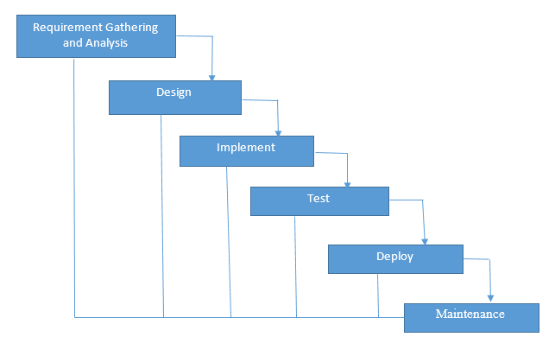

Fig: waterfall model.

## 3.2 Design pattern

I have used MVC (Model View Controller) design patter in this project. It is most used framework done in today’s projects. Both desktop and web-based application is performed by using this design pattern.

## 3.3 Model View Controller Pattern

Model interacts with data. The model doesn’t know about views and controller. When a model is changed, it notifies that a change has been occurred. View is what’s presented to the user and user interacts with the app. Controller finds the data query in model. Controller acts as an intermediary between model and view to process logic and requests. The controller updates the view when the model changes. It also adds event listeners to the view and updates the model when the user manipulates the view.

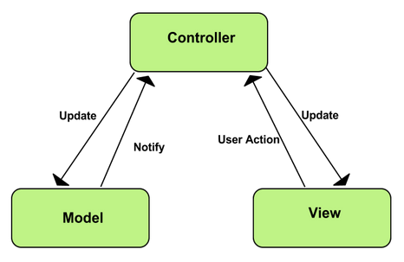

Fig: Model View Controller

## 3.4 System Architecture

System architecture is a conceptual model. It defines the structure, behavior and view of the system. It provides a presentation for the whole system. A system architecture consists of system components and the sub-systems developed, that will work together to implement the overall system.

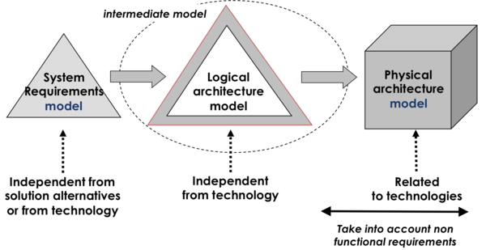

Fig: System Architecture

I choose 3-tier architecture because of following reasons:

* It is more reliable.
* It helps to maintain code easily.
* It provides more opportunity while updating

# Chapter 4: PROJECT PLAN - WORK BREAKDOWN STRUCTURE(WBS)

## 4.1 Work Breakdown Structure

Work breakdown structure is a process of dividing complex projects into small and manageable tasks. I need to allocate time on how I am to finish my project so, WBS helps me in completion of my work.

Online Movie Rental System

Project Management

Analysis

Design

Implementation

Testing

Final Document

Project Plan

Requirement Specification

User Training

Structural Model

Build Database

Unit Testing

Final Report

Risk Management

User case

Behavioral Model

Coding

Integration Testing

Configuration management

Class Diagram

UI Design

Black Box Testing

Proposal Submission

Analysis Specification

Database Design

White Box Testing

NLA

Work Breakdown Structure (WBS)

|  |  |  |
| --- | --- | --- |
| WBS | Task Name | No. Of Days |
| **0** | **Online Movie Rental System** | **108** |
| **1**  1.1  1.2  1.3  1.4 | **Project Management**  Project Plan  Risk Management  Configuration Management  Proposal Submission | **16**  7  4  4  1 |
| **2**  2.1  2.2  2.3  2.4 | **Analysis**  Requirement Specification  Use case  Class Diagram  NLA | **26**  9  3  6  8 |
| **3**  3.1  3.2  3.3 | **Design**  Behavioral Model  UI Design  Database Design | **26**  3  14  6 |
| **4**  4.1  4.2 | **Implementation**  Build Database  Coding | **19**  8  10 |
| **5**  5.1  5.2  5.3  5.4 | **Testing**  Unit Testing  Integration Testing  Black Box Testing  White Box Testing | **7**  2  2  2  1 |
| **6**  6.1 | **Final Documentation**  Project proposal | **11**  11 |

## 4.2 Milestones

Milestones are very necessary for developing a project. It can used for allocating date for each task to complete project. Here I have used and set mile stones for my project.

|  |  |  |  |
| --- | --- | --- | --- |
| S. N | Milestone | Date | Days |
| **1** | **Project Management**  Project Plan  Risk Management  Configuration Management  Proposal management | **3/25/19 8:00Am to 4/9/19 5:00PM**  3/25/19 8:00Am to 3/31/19 5:00PM  4/1/19 8:00Am to 4/4/19 5:00PM  4/5/19 8:00Am to 4/8/19 5:00PM  4/9/19 8:00Am to 4/9/19 5:00PM | **16**  7  4  4  1 |
| **2** | **Analysis**  Requirement specification  Use Case  Class Diagram  NLA | **4/10/19 8:00Am to 5/7/19 5:00PM**  4/10/19 8:00Am to 4/18/19 5:00PM  4/19/19 8:00Am to 4/21/19 5:00PM  4/22/19 8:00Am to 4/27/19 5:00PM  4/28/19 8:00Am to 5/7/19 5:00PM | **26**  9  3  6  8 |
| **3** | **Design**  Behavioral Model  UI Design  Database Design | **5/8/19 8:00Am to 6/2/19 5:00PM**  5/8/19 8:00Am to 5/10/19 5:00PM  5/14/19 8:00Am to 5/27/19 5:00PM  5/28/19 8:00Am to 6/2/19 5:00PM | **26**  3  14  6 |
| **4** | **Implementation**  Build Database  Coding | **6/2/19 8:00Am to 6/21/19 5:00PM**  6/3/19 8:00Am to 6/10/19 5:00PM  6/12/19 8:00Am to 6/21/19 5:00PM | **19**  8  10 |
| **5** | **Testing**  Unit testing  Integration Testing  Black Box Testing  White Box Testing | **6/22/19 8:00Am to 6/28/19 5:00PM**  6/22/19 8:00Am to 6/23/19 5:00PM  6/24/19 8:00Am to 6/25/19 5:00PM  6/26/19 8:00Am to 6/27/19 5:00PM  6/28/19 8:00Am to 6/28/19 5:00PM | **7**  2  2  2  1 |
| **6** | **Final Documentation**  Project submission | **6/29/19 8:00Am to 7/9/19 5:00PM**  6/29/19 8:00Am to 7/9/19 5:00PM | **11**  11 |

Description of Milestones

* Project Management:

I allocated 16 days for this task I.e. 7 days for project plan, 4 days for risk management, 4 days for configuration management and 1 day for proposal.

* Analysis:

I allocated 26 days for this task i.e. 3 days for use case diagram, 14 days for class diagram and 6 days for natural language specification.

* Design:

I allocated 26 days for this task i.e. 3 days for structural model, 14 days for behavioral model, 6 days for UI design and 6 days for database design.

* Implementation:

I allocated 19 days for implementation i.e. 8 days for build database and 10 days for coding.

* Testing:

I allocated 7 days for testing i.e. 2 days for unit testing, 2 days for integration testing, 2 days for black box testing and 1 days for white box testing.

* Final Document:

I allocated 11 days for final document project submitting.

## 4.3 Scheduling: GANTT Chart

In this section of my project, I will divide the days and schedule them for my working days. So, for the scheduling purpose I prepared time estimation tale and Gantt chart.

### 4.3.1 Time Estimation Table

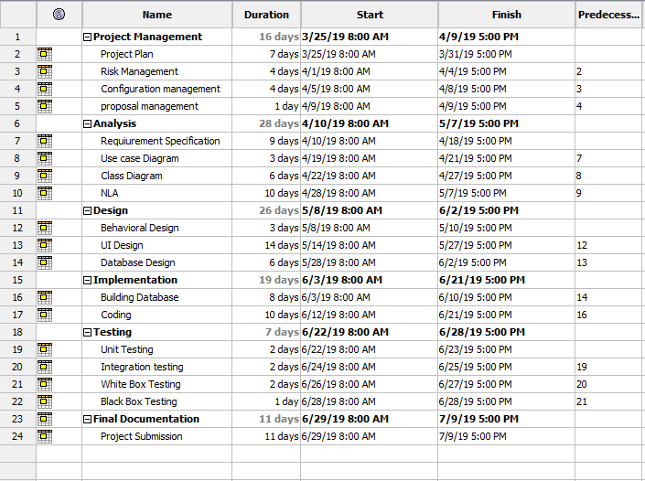

Fig: time estimation

### 4.3.2 GANTT Chart

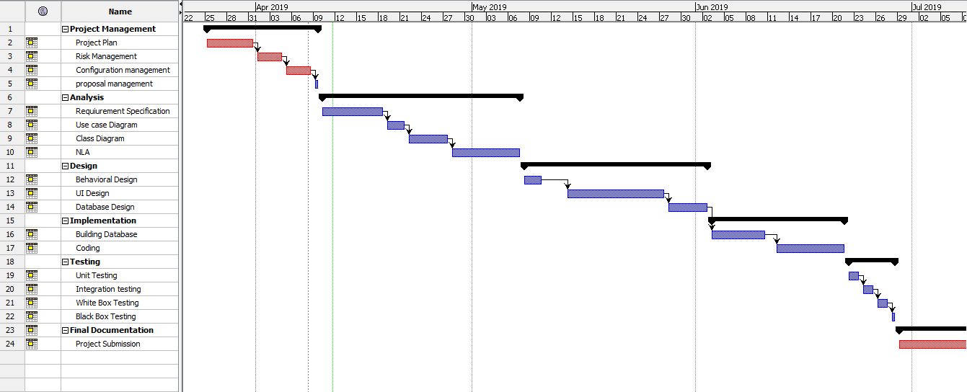

Fig: Gantt chart

# Chapter 5: RISK MANAGEMENT

Risk management is the process of identifying, evaluating and prioritizing risks to minimize the probability of impact and maximizing realization of opportunities.

Impact = Likelihood*Consequence

Risk likelihood are shown below:

|  |  |
| --- | --- |
| likelihood | value |
| Low | 1 |
| medium | 2 |
| high | 3 |

Risk consequence values are shown below:

|  |  |
| --- | --- |
| Consequence | Value |
| Very low | 1 |
| low | 2 |
| Medium | 3 |
| High | 4 |
| Very High | 5 |

Risk Consequence values are shown below:

|  |  |  |  |  |  |
| --- | --- | --- | --- | --- | --- |
| S. N | Risks | Likelihood | Consequences | Impact | Solution |
| 1 | Insufficient resources | 2 | 3 | 6 | Collect all required resources |
| 2 | Hard disk failure | 1 | 2 | 2 | Backup plan |
| 3 | Server failure | 1 | 3 | 3 | Online backup plan |
| 4 | Lack of skill | 1 | 3 | 3 | Providing training for employees |
| 5 | scheduling problem | 2 | 4 | 8 | Dividing tasks in different schedule |

# Chapter 6: CONFIGURATION MANAGEMENT

Configuration management is a process for establishing and maintaining consistency of a product’s performance, functional, design and operational information.

This application helps in maintaining the functionality and operation. The main advantage of configuration management is to help in reliability.

Below is the files name that I have uploaded in GitHub:

(Link:)

# CONCLUSION

Online Movie Rental System is user friendly web application where you can rent a movie anytime anywhere. Its features make customer easy to search, rent and buy movie. Admin can make changes to the user. Waterfall methodology and design pattern MVC is used in this project. Its only limitation is that it’s not currently in use in foreign countries.

# REFERENCE & BIBLIOGRAPHIES

Google. (2019). MVC architecture.[online]Available at:

[https://developer.chrome.com/apps/app_frameworks](https://developer.chrome.com/apps/app_frameworks%5baccessed) [accessed 6 April. 2019]

SEoK. (2019). system architecture.[online]Available at:

<https://www.sebokwiki.org/wiki/System_Architecture> [accessed 6 April. 2019]